Exercise 1:
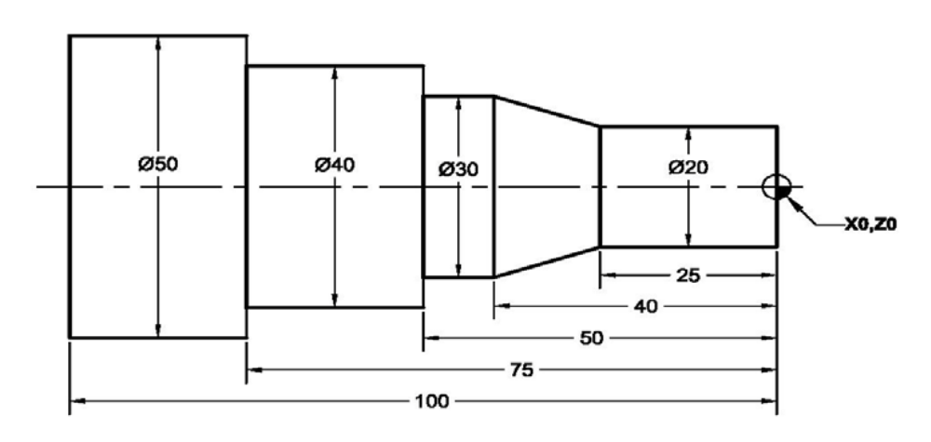
Ordinary Cycle
O1234
G21
G99
G28 U0 W0
M06 T0101
M03 S1200
G00 X55 Z5
Z0
G01 X-1 F.1
G01 Z1
G00 X50
G01 Z-100 F.1
G01 X51 Z-100
G00 Z1
G00 X48
G01 Z-75 F.1
G01 X49 Z-75
G00 Z1
G00 X46
G01 Z-75 F.1
G01 X47 Z-75
G00 Z1
G00 X44
G01 Z-75 F.1
G01 X45 Z-75
G00 Z1
G00 X42
G01 Z-75 F.1
G01 X43 Z-75
G00 Z1
G00 X40
G01 Z-75 F.1
G01 X41 Z-75
G00 Z1
G00 X38
G01 Z-50 F.1
G01 X39 Z-50
G00 Z1
G00 X36
G01 Z-50 F.1
G01 X37 Z-50
G00 Z1
G00 X34
G01 Z-50 F.1
G01 X35 Z-50
G00 Z1
G00 X32
G01 Z-50 F.1
G01 X33 Z-50
G00 Z1
G00 X30
G01 Z-50 F.1
G01 X31 Z-50
G00 Z1
G00 X28
G01 Z-25 F.1
G01 X29 Z-25
G00 Z1
G00 X26
G01 Z-25 F.1
G01 X27 Z-25
G00 Z1
G00 X24
G01 Z-25 F.1
G01 X25 Z-25
G00 Z1
G00 X22
G01 Z-25 F.1
G01 X23 Z-25
G00 Z1
G00 X20
G01 Z-25 F.1
G01 X21 Z-25
G00 Z1
G00 X28 Z-24
G01 X30 Z-40 F.1
G01 X31 Z-40
G00 Z-24
G00 X26
G01 X30 Z-40 F.1
G01 X31 Z-40
G00 Z-24
G00 X24
G01 X30 Z-40 F.1
G01 X31 Z-40
G00 Z-24
G00 X22
G01 X30 Z-40 F.1
G01 X31 Z-40
G00 Z-24
G00 X20
G01 X30 Z-40F.1
G01 X31 Z-40
G00 Z-24
G00 Z1
G28 U0 W0
M05
M30

Exercise 2:
G71 Canned Cycle
O1234
G21
G99
G28 U0 W0
M06 T0101
M03 S1200
G00 X55 Z5
Z0
G01 X-1 F.1
G01 Z1
G00 X52
G71 U0.5 R1
G71 P10 Q20 U.1 W.1 F.1
N10 G01 X20 Z0 F.1
Z-25
X30 Z-40
Z-50
X40
Z-75
X50
Z-100
X55
N20 G00 Z5
G70 P10 Q20 F0.05
G28 U0 W0
M05
M30

Exercise 3:
G72 Canned Cycle
O1234
G21
G99
G28 U0 W0
M06 T0101
M03 S1200
G00 X55 Z5
Z0
G01 X-1 F.1
G01 Z1
G00 X55
G72 W0.5 R1
G72 P10 Q20 U.1 W.1 F.1
N10 G01 X50 Z-100 F.1
Z-75
X40
Z-50
X30
Z-40
X20 Z-25
Z0
Z5
N20 G00 X55
G70 P10 Q20 F0.05
G28 U0 W0
M05
M30

Exercise 4:
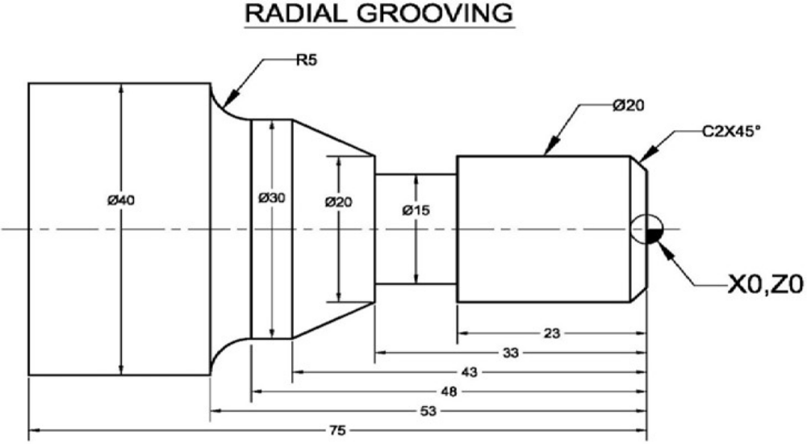
O1234
G21
G99
G28 U0 W0
M06 T0101
M03 S1200
G00 X45 Z5
Z0
G01 X-1 F0.1
Z2
G00 X42
G71 U0.5 R1
G71 P10 Q20 U0.2 W0.2 F0.1
N10 G01 X16 Z0
X20 Z-2
Z-33
X30 Z-43
Z-48
G02 X40 Z-53 R5
G01 Z-75
G01 X45
N20 Z2
G28 U0 W0
M05
M06 T0202
M03 S2000
G00 X42 Z2
G70 P10 Q20 F0.1
G28 U0 W0
M05
M06 T0303
M03 S800
G00 X21 Z-33
G75 R1
G75 X15 Z-26 P1000 Q500 R0 F0.1
G28 U0 W0
M05
M30

Exercise 5:
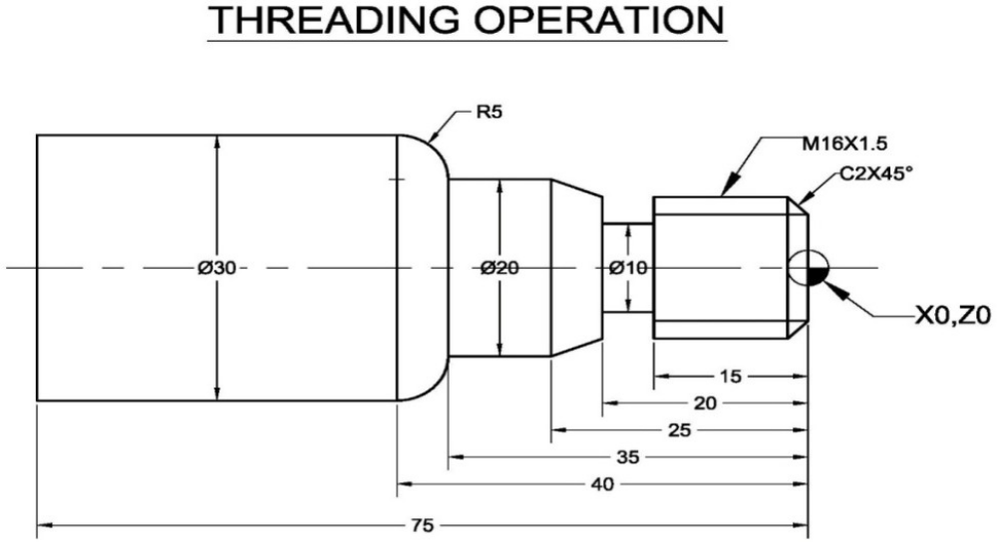
O1234
G21
G99
G28 U0 W0
M06 T0101
M03 S1200
G00 X35 Z5
Z0
G01 X-1 F0.1
Z2
G00 X35
G71 U0.5 R1.0
G71 P10 Q20 U0.2 W0.2 F0.1
N10 G01 X14 Z0
X16 Z-2
Z-20
X20 Z-25
Z-35
G03 X30 Z-40 R5
G01 Z-75
N20 G01 X35
G28 U0 W0
M05
M06 T0202
M03 S2000
G00 X35 Z2
G70 P10 Q20 F0.05
G00 X35
G28 U0 W0
M05
M06 T0303
M03 S800
G00 X35 Z-20
X17
G75 R1.0
G75 X10 Z-18 P1000 Q500 F0.1
G00 X35
G28 U0 W0
M05
M06 T0404
M03 S500
G00 X16 Z5
G76 P030060 Q100 R0.1
G76 X14.16 Z-17 P920 Q200 R0 F1.5
G00 X17
G28 U0 W0
M05
M30

Exercise 6:
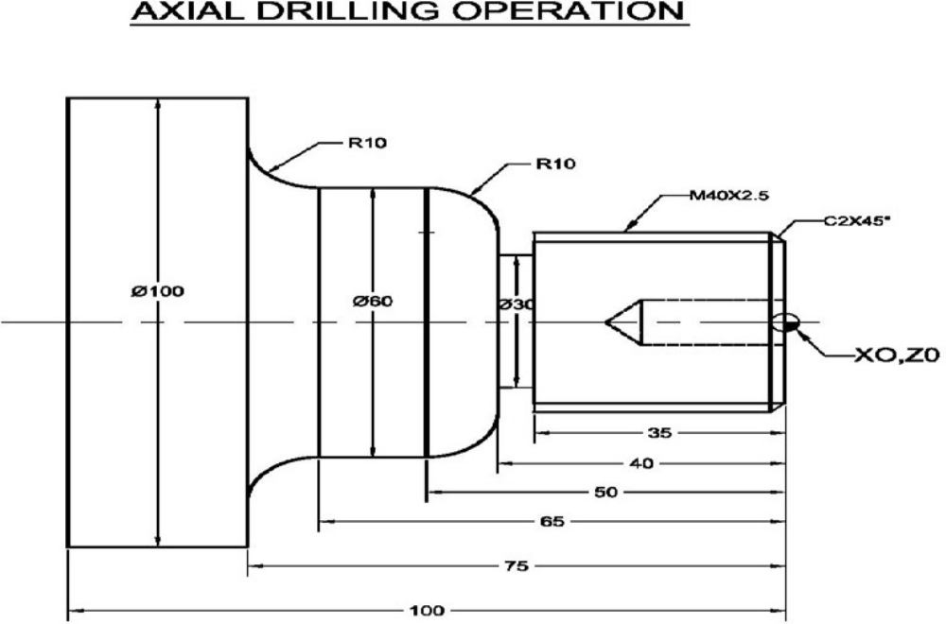
O1238
G21
G99
G28 U0 W0
M06 T0101
M03 S1200
G00 X105 Z5
Z0
G01 X-1 F0.1
Z2
G00 X105
G71 U0.5 R1.0
G71 P10 Q20 U0.1 W0.1 F0.1
N10 G01 X36 Z0
X40 Z-2
Z-40
G03 X60 Z-50 R10
G01 Z-65
G02 X80 Z-75 R10
G01 X100
Z-100
N20 X105
G28 U0 W0
M05
M06 T0202
M03 S2000
G00 X105 Z5
G70 P10 Q20 F0.05
G00 X105
G28 U0 W0
M05
M06 T0303
M03 S800
G00 X105 Z-40
G00 X41
G75 R1
G75 X30 Z-38 P1000 Q500 R0 F0.1
G00 X105
G28 U0 W0
M05
M06 T0404
M03 S500
G00 X40 Z50
G00 Z2
G76 P030060 Q100 R0.1
G76 X36.93 Z-37 P1533 Q200 F2.5
G00 X105
G28 U0 W0
M05
M06 T0505
M03 S700
G00 X0 Z50
Z2
G74 R1.0
G74 Z-30 Q1000 F0.1
G01 Z2
G28 U0 W0
M05
M30

Exercise 7:
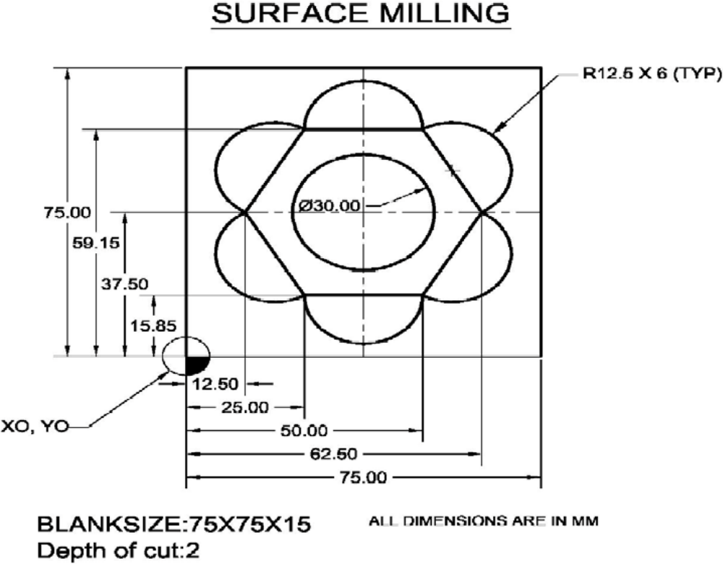
O1234
G21
G98
G91 G28 Z0
G91 G28 X0 Y0
M06 T01
M03 S1200
G00 G55 G90 X0 Y0
G43 H1 Z13
Z2
G40 G00 X25 Y15.85
G01 Z-2.0 F20
G01 X12.5 Y37.5 F100
G01 X25.0 Y59.15
G01 X50.0 Y59.15
G01 X62.25 Y37.5
G01 X50.0 Y15.85
G01 X25.0 Y15.85
G02 X12.5 Y37.5 R12.5
G02 X25.0 Y59.15 R12.5
G02 X50.0 Y59.15 R12.5
G02 X62.5 Y37.5 R12.5
G02 X50.0 Y15.85 R12.5
G02 X25.0 Y15.85 R12.5
G01 Z2
G00 X22.5 Y37.5
G01 Z-2 F20
G02 X22.5 Y37.5 I15 J0
G01 Z2
G00 Z100
G91 G28 Z0
G91 G28 X0 Y0
M05
M30

Exercise 8:
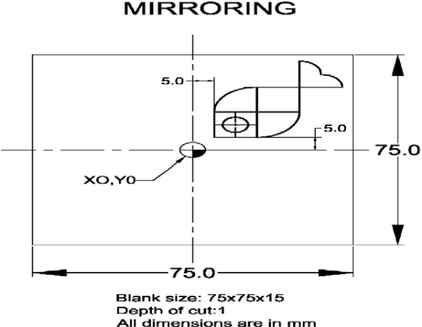 | 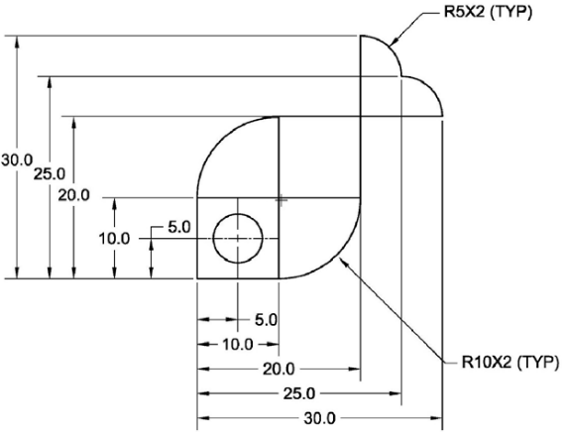
O1234
G21
G98
G00 G91 G28 Z0
G00 G91 G28 X0 Y0
M06 T01
G00 G90 G55 X0 Y0
G43 H1 Z13
M03 S1500
Z5
G01 Z0.0 F100
M98P0014000
M70
M98P0014000
M80
M71
M98P0014000
M81
M70
M71
M98P0014000
M80
M81
G00 G90 Z5
G00 G91 G28 Z0
G00 G91 G28 X0 Y0
M05
M30
O4000
G00 G90 X5 Y5
G01 G91 Z-0.5 F100
G01 G90 X5 Y15
G02 X15 Y25 R10
G01 X35
G03 X30 Y30 R5
G03 X25 Y35 R5
G01 Y15
G02 X15 Y5 R10
G01 X5 Y5
G01 X15 Y5
G01 Y15
G01 X5
G00 Z0
G00 X10 Y10
G01 G91 Z-0.5 F100
G00 G90 Z0
M99

